NL2SQL

Contents

Introduction 1

Background. 1

Goal. 2

Milestones. 2

OMOP CDM – ODHSI 3

Dataset 4

Chia 4

Spider 6

SParC 6

Architecture 6

Flow 6

Named Entity Recognition 7

Negation Detection 7

Entity Linking 7

Relation Extraction 7

Template Classification 7

KGQA 7

Data Preprocessing 8

Entities and Relations 8

Question Answering 9

Complex Knowledge Graph QA 9

Attention Based QA 9

Relation Extraction 9

# Introduction

Background.

The ability to translate natural language to Structured Query Language (SQL) has received extensive attention lately, especially with the recent success of deep learning technologies. It has many potential use-cases: it makes data-driven insights accessible to users without coding skills, it reduces time to insights in a domain, and overall, it improves the value of accumulated data. In the healthcare domain particularly, it could facilitate collaboration and execution of such tasks using clinical databases such as electronic health records (EHRs).

Goal.

The main objective of this project is to work towards the development of a natural language interface that can parse a user question or statement, transform it into a structured criteria representation and produce an executable clinical data query represented as an SQL query conforming to an EHR Common Data Model. Experiments and data.

We plan to make use of well-known libraries such as Spark NLP and (Sci)spaCy, which contain a plethora of useful models and pipelines for processing text data and performing a number of tasks, including named entity recognition (or NER), spelling correction, and text classification. For this project, we will firstly concentrate on the evaluation of the performance of some of the available models for (1) recognizing clinical entities, (2) assigning the recognized entities to the right clinical domain, and (3) recommending clinical codes for such entities. We have a large annotated (publicly-available) dataset of eligibility criteria from over 1,000 clinical trials that we will make use for this evaluation. Other related datasets (if available) can be looked at. Secondly, we will test the robustness of such models for correcting misspelled clinical terms by introducing “artificial” noise into the data. Finally, if time allows, we will seek to implement and evaluate some of the approaches for translating natual text into SQL queries, for which we have our various databases for testing the execution of queries.

Milestones.

(1) Install libraries and get familiar with them and the dataset(s). (2) Implement and evaluate the performance of two different models (ideally, from two different libraries) for recognizing clinical entities in a corpus of eligibility criteria (including spell corrections). (3) Implement NER models and evaluate the assignment of the correct domain to the named entity (NER). (4) Evaluate system for recommending clinical codes for each entity. (5) Build and test relation extraction models between the identified entities. (6) Build a translation method that convert extracted entities and relations into an SQL query.

# OMOP CDM – ODHSI

<https://ohdsi.github.io/CommonDataModel/>

<https://www.ohdsi.org/wp-content/uploads/2019/09/OHDSI2019_MiaoChen_32.pdf>

BioBert performs the best for Text Classification for Identifying Eligibility Criteria in Clinical Trial Protocols using Pre-trained Deep Learning Models.

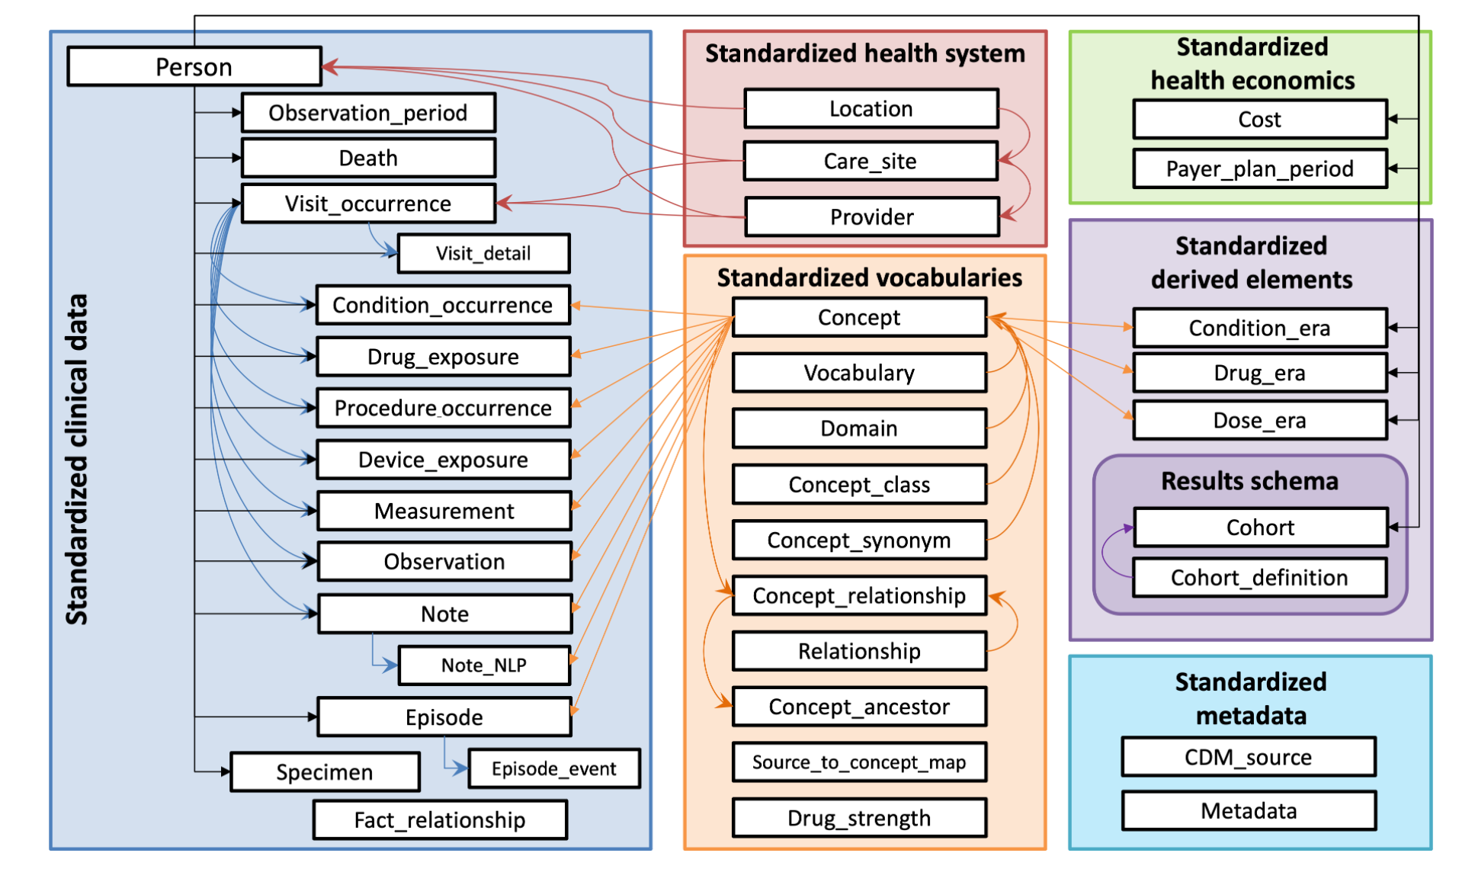

Patient Centric Data Model so contains records that actually happened.

* Blue is the standard data for the patients
* Red is the data pertaining to which care site or location the patient went to
* Peach is the Vocabulary of the Data
  + When you process a CDM you process on version of the vocabulary
* Purple is the derived from blue tables
* Green is the payment plan
* Cyan tells the version of the CDM i.e v5.3 and meta data such as OMOP dump

Helpful Info:

* All Blue (Standardized Clinical) tables have Person_id identifier for each table (As Patient Centric Data)
* Also have unique domain identifiers in the standardized clinical tables
* Concept_Id for integration with Vocabulary. Foreign Key into standard vocabulary

Useful Links:

<https://athena.ohdsi.org/search-terms/terms?domain=Measurement>

# Dataset

## Chia

Created By: <https://github.com/WengLab-InformaticsResearch/CHIA>

Article: <https://www.nature.com/articles/s41597-020-00620-0>

Data: <https://figshare.com/articles/dataset/Chia_Annotated_Datasets/11855817>

Visualize: BRAT: a Web-based Tool for NLP-Assisted Text Annotation <https://aclanthology.org/E12-2021.pdf>

Numerical

* Annotated corpus of patient eligibility criteria extracted from 1,000 interventional clinical trials.
* 12409 Eligibility Criteria
* 41487 distinctive entities
* 15 entity types
* 25017 relationships of 12 relationship types
* Criterion in DAG form and can be converted to Boolean Logic

Background

* Clinical trial eligibility criteria specify rules for screening clinical trial participants and play a central role in clinical research in that they are interpreted, implemented, and adapted by multiple stakeholders

Annotations

* Boundaries of semantic categories of named entities
* Boolean operators to form DB query logic

Contribution

* Chia can serve as a shared benchmark to develop and test future machine learning, rule-based, or hybrid methods for information extraction from free-text clinical trial eligibility criteria

Structure

* The entity categories are aligned with the domain names defined by the Observational Health Data Sciences and Informatics (OHDSI) OMOP Common Data Model (CDM), which is widely used in the medical research community for health data standardization.

<https://ohdsi.github.io/CommonDataModel/> (First Para)

* 3 Components: Entities, Relationships and Annotation Graphs.
* Entities
  + Domain
    - Represent eight domains, i.e., observation, condition, person, device, drug, visit, procedure, and measurement
  + Field
    - Represents property of applicable domain entity
    - E.g. “Hemoglobin <8 g/dL” includes a *Domain* entity “Hemoglobin” and a *Field* entity “ <8 g/dL.”
  + Construct
    - Defines modifiers such as negation and repetition e.g., Negation Entity inverts Boolean logic of Domain Entity being modified.
* Relationships
  + Boolean Operators (And Or)
  + 10 Other Relationships
  + SUBSUMES (Wont use)
  + HAS_NEGATION (target argument is negation)
  + HAS_MULTIPLIER (Wont Use)
  + HAS_QUALIFIER
  + HAS_VALUE
  + HAS_TEMPORAL
  + HAS_INDEX (target argument is reference point)
  + HAS_MOOD
  + HAS_CONTEXT (target argument is observation and not included in above rshps)
  + HAS_SCOPE

NOT is not a relationship and is a Entity as mentioned in Construct.

* Annotation Graph
  + One trial represented by 2 AG’s (Inclusion and Exclusion Criteria)
  + Entities form nodes and relationships form edges
  + Parsing of a graph runs from root to leaf nodes, forming a single Boolean expression. If that expression evaluates to true when fed the data from one patient, it means such patient is eligible (if inclusion criteria) or is ineligible (if exclusion criteria).

## Spider

<https://yale-lily.github.io/spider>

## SParC

<https://yale-lily.github.io/sparc>

# Architecture

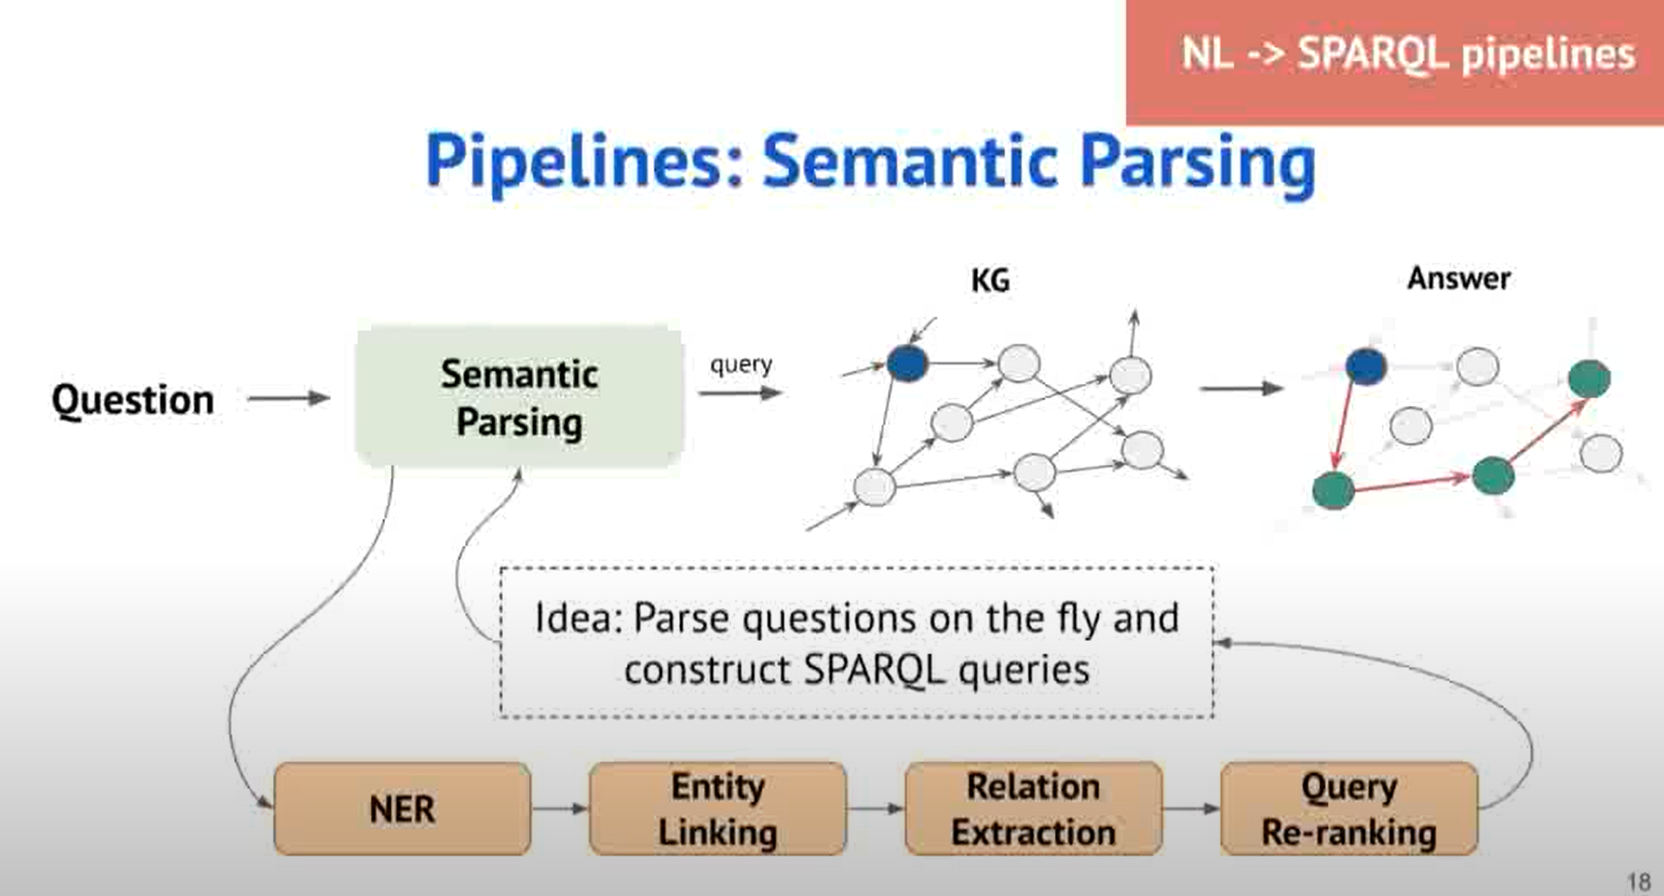

## 

## Flow

Currently, the flow of the model is similar to the one showed above for the initial stages. We will first begin with getting the raw text which we will pass through our NER model to give us the entities based on tables and columns of the OMOP CDM. We will then extract the relations between the extracted entities and construct a knowledge graph to understand the general structure of the queries and maybe use the graph to answer possible questions/queries. These answers of queries will help in classifying the template for SQL. General template classification looks into six components to answer or classify which are the following:

1. SELECT column

2. AGGREGATION: None, COUNT, SUM, AVG, MIN, MAX

3. Number of WHERE conditions: 0, 1, 2, 3

4. WHERE column

5. WHERE OPERATORS: =, <, >

6. WHERE VALUE: a textspan (the beginning and the end position of the span using probability) in the NL question. It depends on both selected where-column and where operators.

These 6 SQL components can be learned through different ways which we will further look into. A few ideas to find these are:

## Named Entity Recognition

* BioBert
* MedBert
* RoBERTa

## Negation Detection

* NegBERT

## Entity Linking

## Relation Extraction

* R-BERT (<https://arxiv.org/pdf/1905.08284.pdf>)
* https://github.com/jmshen1994/R-BERT
* <https://huggingface.co/mmoradi/Robust-Biomed-RoBERTa-RelationClassification>
* http://nlpprogress.com/english/relationship_extraction.html

## Template Classification

## KGQA

# Data Preprocessing

Bring data into the correct format to use in NER and RE and to look at general Knowledge Graph that is being constructed.

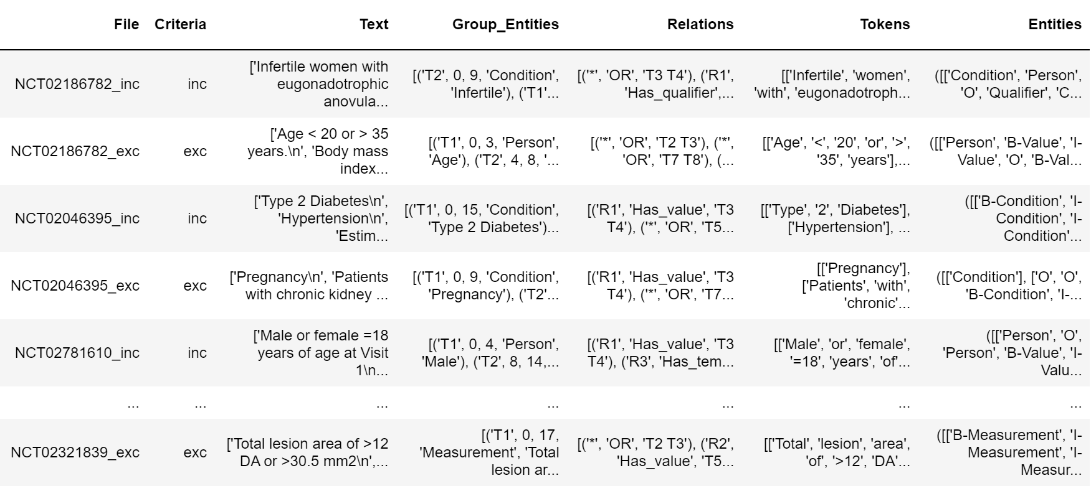

## Entities and Relations

We begin by filtering the entities we want to classify with our Named Entity Recognition model as shown in the list below. These entities also affect the relations we look at as we only look at the relations which have both entities we have filtered. We also have a fixed list of relations we will look at only for our relation prediction.

Entities Filtered

* Condition
* Drug
* Procedure
* Measurement
* Observation
* Person
* Device
* Value
* Temporal
* Qualifier
* Negation

Relations Filtered

* OR
* AND
* Has_qualifier
* Has_value
* Has_negation
* Has_temporal
* Has_context

## Column Information

The data comes from 2 different folders 1) Chia_with_scope 2) Chia_without_scope. Each of these folders has 4004 files (4 files are for meta data which we don’t use). Of the 4000 files we have 2000 ann files and 2000 txt files. There is a file code for each file which has 2 criteria’s Inclusive or Exclusive.

Explanation of Inclusive and Exclusive Criteria’s

The entities and relationships in each trial’s eligibility criteria can be represented as two *Annotation Graphs (AGs)* (one for inclusion criteria and one for exclusion criteria) to computationally represent the query logic.

If that expression evaluates to true when fed the data from one patient, it means such patient is eligible (if inclusion criteria) or is ineligible (if exclusion criteria)

1. File
   * The file number
2. Criteria
   * Either Inclusive or Exclusive criteria
3. Text
   * Raw text of each sentence. Each sentence is a different element in an array
4. Group_Entities
   * All entities that we filtered out for that file in the form of a list
5. Relations
   * All relations that we filtered out for that file in the form of a list
6. Tokens
   * All tokens which we labelled as entities/non entities in form of a list after removing punctuation.
7. Entities
   * Tuple where first element is list of all the labelled entities for each word in each sentence in the file and the second element is the labelled entity identities such as T1, T2 etc so we can use it for relation classification/extraction.

# Question Answering

## Complex Knowledge Graph QA

Pros

* + Independent of KG Size
  + Fast and Parallelizable
  + Explainable Query Results

Cons

* + Hard Coded to KG Schema (Ontology)
  + Each new question formulation will require a new template
  + Manual Curation of templates

Notes:

If edge is missing in KG then can’t predict a certain solution using QA.

## Attention Based QA

* Query - Table/Column Aware Representation using Attention
* <https://towardsdatascience.com/text-to-sql-learning-to-query-tables-with-natural-language-7d714e60a70d>

# Relation Extraction

Example

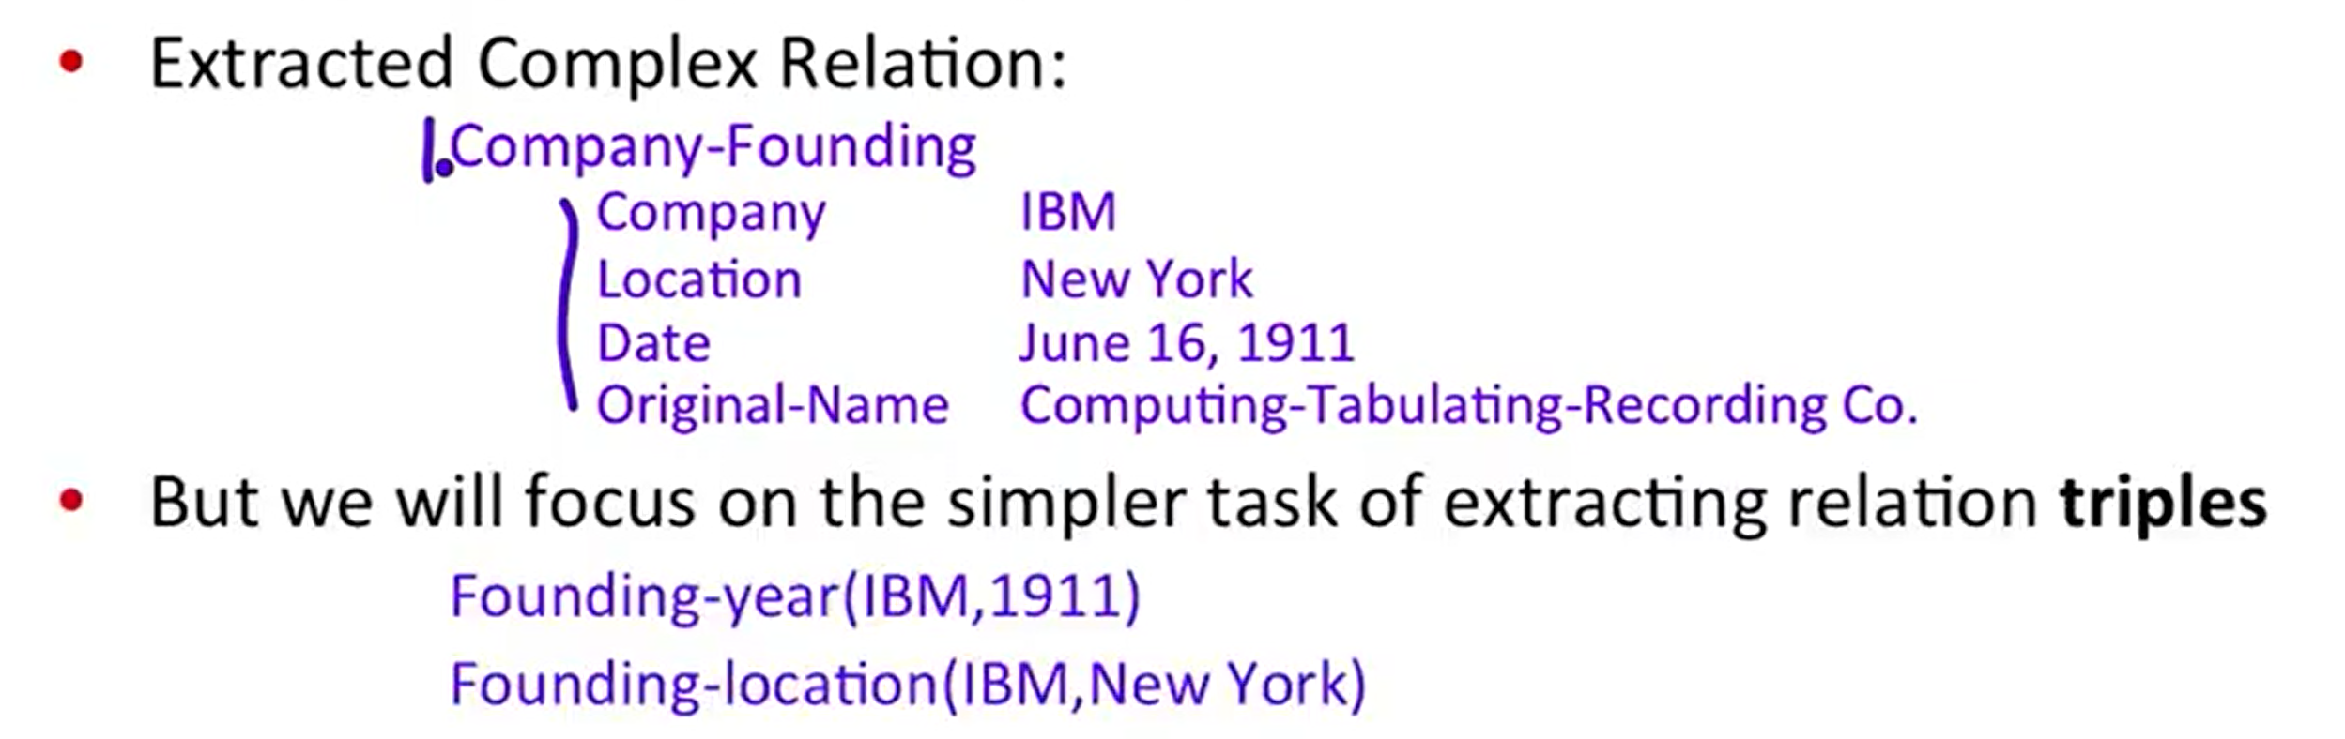

* Need for creating a knowledge base or knowledge graph
* Useful for structured databases
* Useful in Question Answering as well (KGAQ)

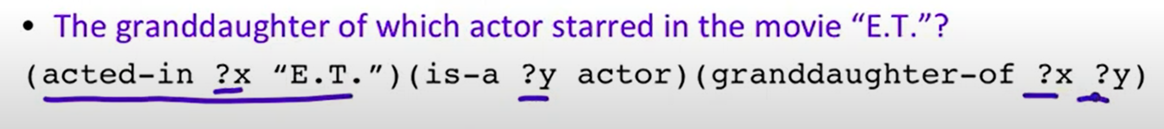

Medical Specific Relations by UMLS

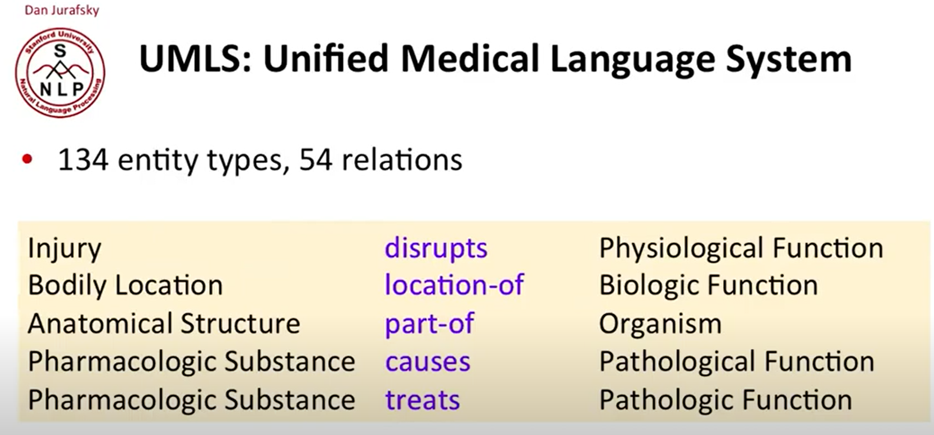

General Relations posed by ACE

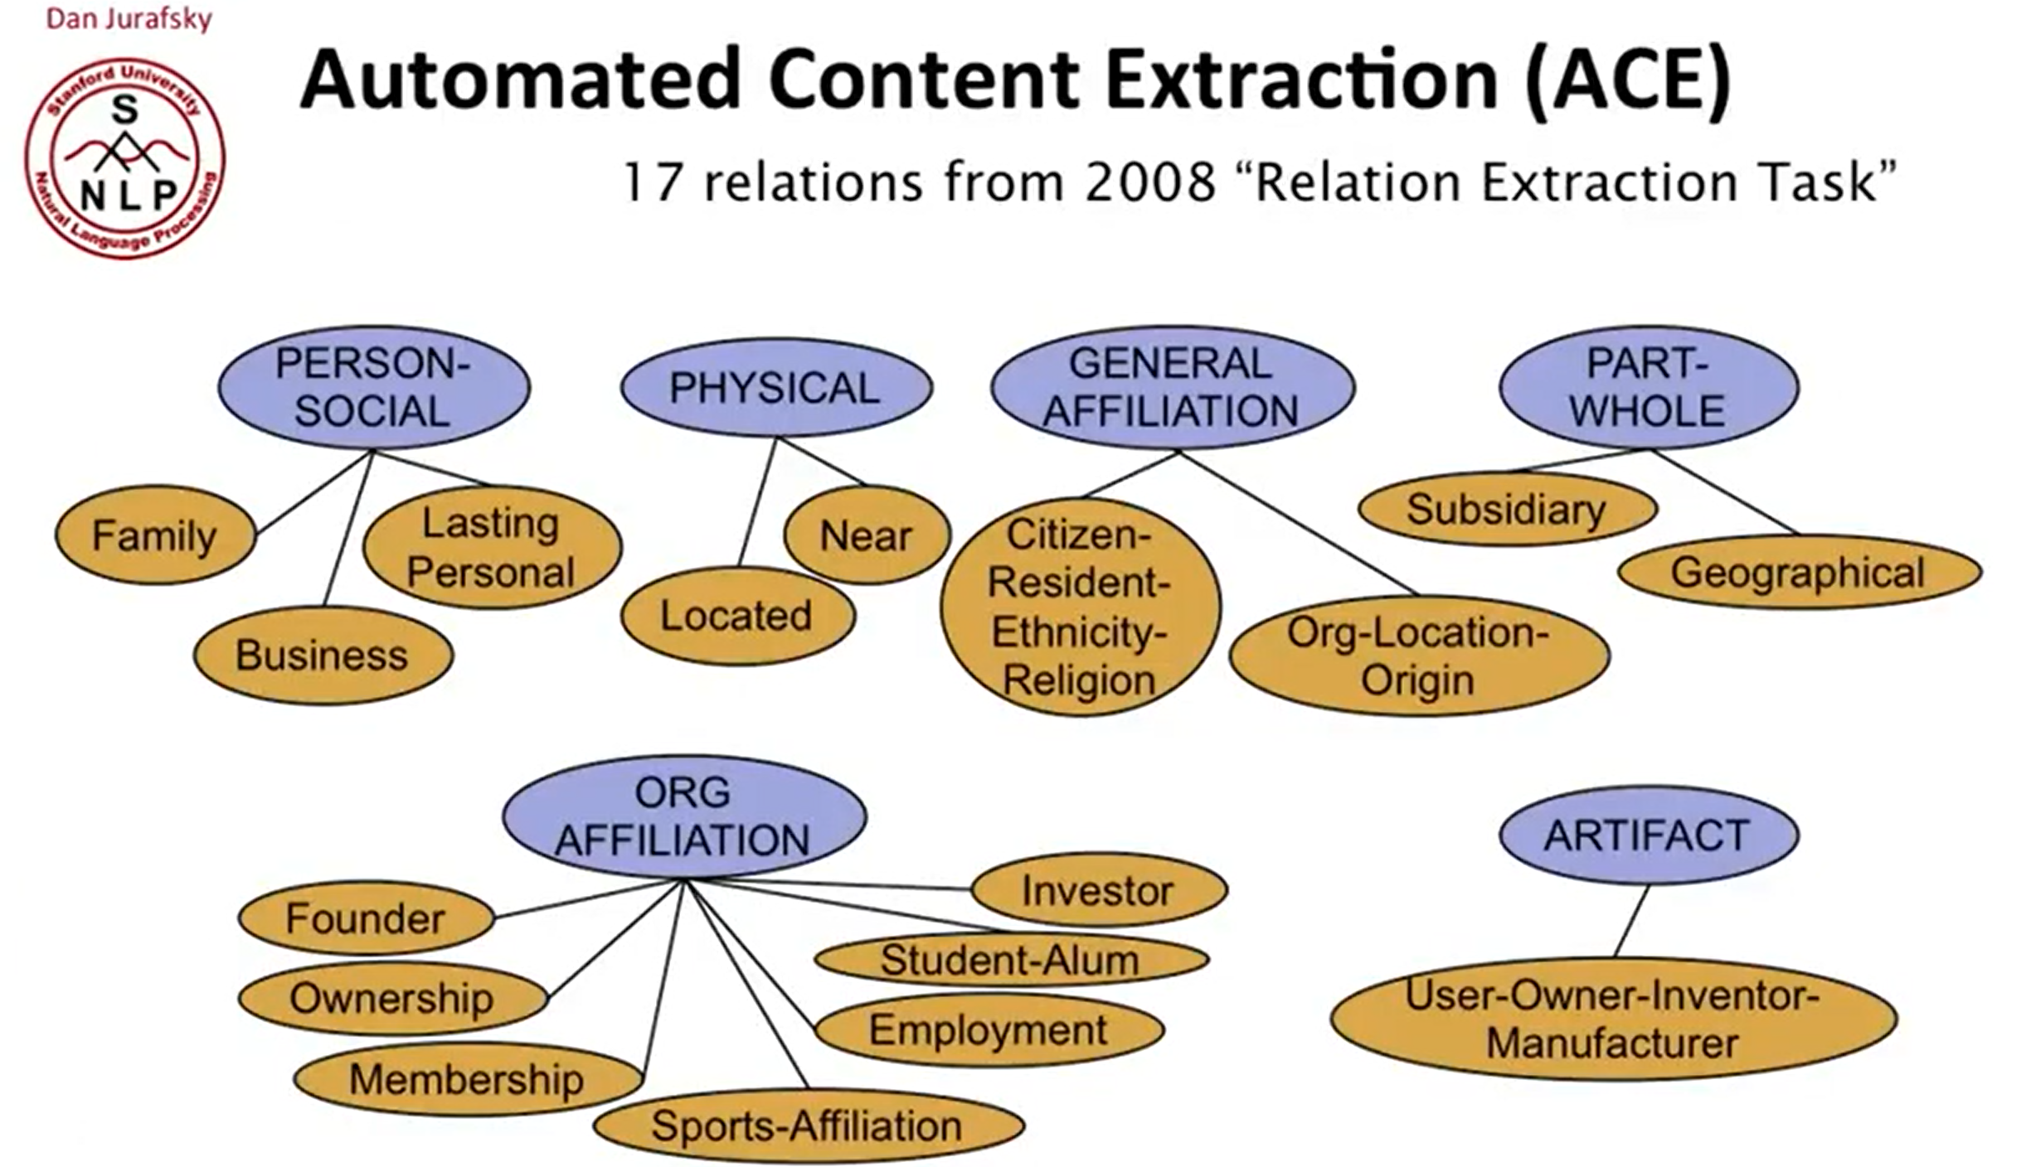

Ontological Relations

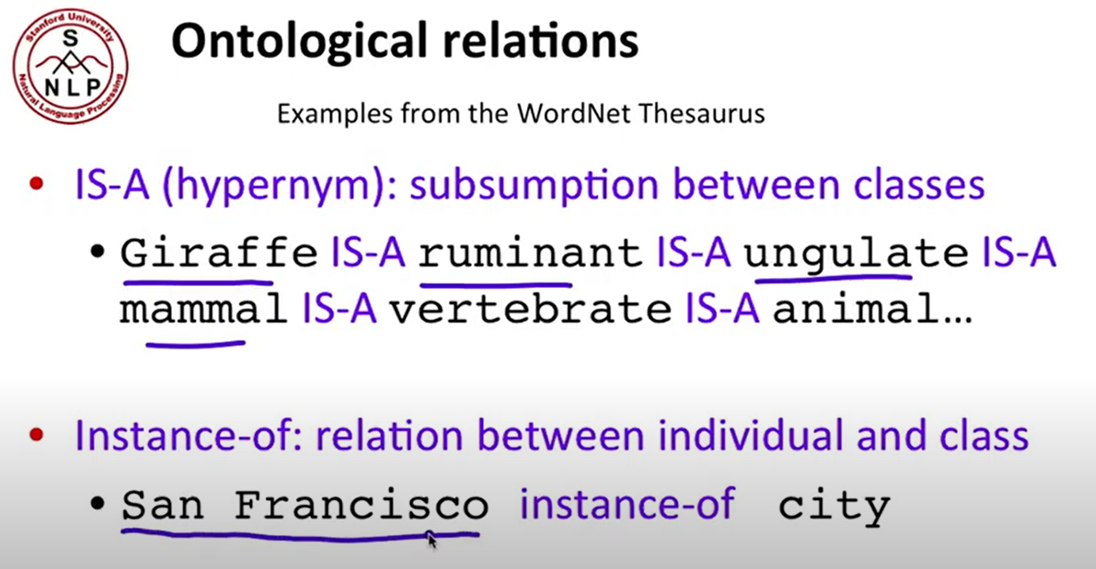

How to build Relation Extractions

